Mitchell Fontaine

CS-330

09/12/2024

2-3 Milestone One: Project Proposal

Selected Image:

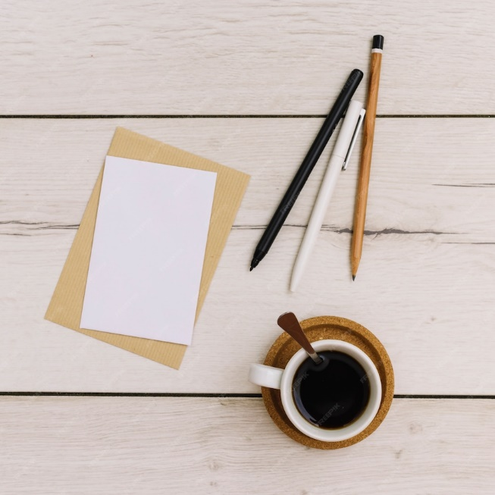

The image I selected shows a desk with two pieces of paper, two pens, one pencil, and a coffee cup with a coaster underneath it. These items are a good choice for this project because they are not overly complex but still contain essential elements that I will need to recreate for the final project. The desk and two pieces of paper will be recreated using the plane shape. The pencil will use a cylinder with a cone for the tip and a different colored cylinder as the eraser. The two pens will be made with a cylinder and a cone for the tip with the cap being made up of another cylinder with a plane or small box for the clip. The coffee cup will be recreated with a cylinder for the body and a torus shape for the lip. The final piece is the coaster, which could be made using another cylinder, but I may use a plane with a torus due to its raised edges.